EXPT : 4 | EXPLORATORY DATA ANALYSIS (EDA) – DATA INSPECTION, FILTERING, STATISTICAL ANALYSIS AND CORRELATION
DATE :

AIM
To perform data inspection, filtering, grouping, aggregation, descriptive statistical analysis, and correlation analysis using Pandas and visualize the results using Matplotlib.
ALGORITHM
- Start the program and import required libraries.
- Load the sales dataset and display its basic information.
- Check the dataset shape and data types.
- Filter products based on price and product category.
- Sort products based on their ratings.
- Create a bar chart for the top 10 rated products.
- Calculate statistics such as mean, median, mode, and standard deviation.
- Calculate average ratings for each product category.
- Create visualizations using a line chart and scatter plot.
- Analyze correlation between review count and rating, then stop.
CODE
import pandas as pd
df=pd.read_csv("C: /Users/ramya/Downloads/sales data.xlsx")

# Display first five rows
print(df.head())

# Display dataset dimensions
print(df.shape)

# Check column data types
df.dtypes
# Display high price products
high_price = df[df["price"] > 490]
print(high_price)

# Display electronics products
electronics_products = df[df["product_category"] == "Electronics"]
print(electronics_products)

# Sort ratings descending
sorted_df = df.sort_values(
by="rating",
ascending=False
)
print(sorted_df)

# Create bar chart top products
import matplotlib.pyplot as plt
sorted_df = df.sort_values(by="rating", ascending=False)
plt.figure(figsize=(10,5))
plt.bar(sorted_df["product_id"].head(10).astype(str),
sorted_df["rating"].head(10))
plt.title("Top 10 Products by Rating")
plt.xlabel("Product ID")
plt.ylabel("Rating")
plt.xticks(rotation=45)
plt.show()
# Calculate average, price variation
print("Mean =", df["price"].mean())
print("Median =", df["price"].median())
print("Mode =", df["price"].mode())
print("Standard Deviation =", df["price"].std())
df.describe()

# Calculate category average rating
category_avg = df.groupby(
"product_category"
)["rating"].mean()
print(category_avg)

# Create line chart ratings
category_avg = df.groupby("product_category")["rating"].mean()
plt.figure(figsize=(8,5))
plt.plot(category_avg.index, category_avg.values, marker='o', linewidth=2)
plt.title("Average Rating by Product Category")
plt.xlabel("Product Category")
plt.ylabel("Average Rating")
plt.xticks(rotation=45)
plt.grid(True)
plt.show()
# Calculate correlation
corr = df[[
"rating",
"review_count"
]].corr()
print(corr)

# Create scatter plot
plt.figure(figsize=(8,5))
plt.scatter(df["review_count"],
df["rating"],
s=5,
alpha=0.3)
plt.title("Rating vs Review Count")
plt.xlabel("Review Count")
plt.ylabel("Rating")
plt.show()

OUTPUT
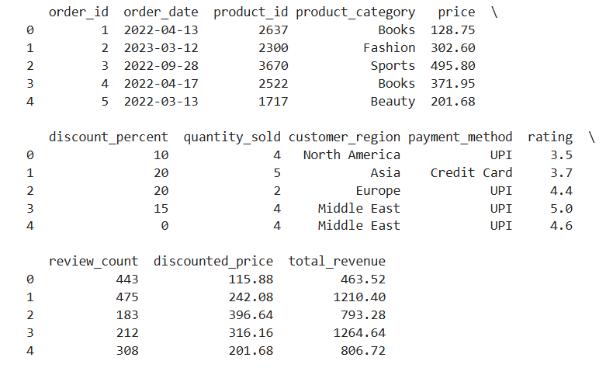
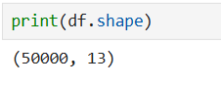

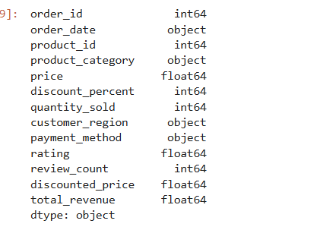

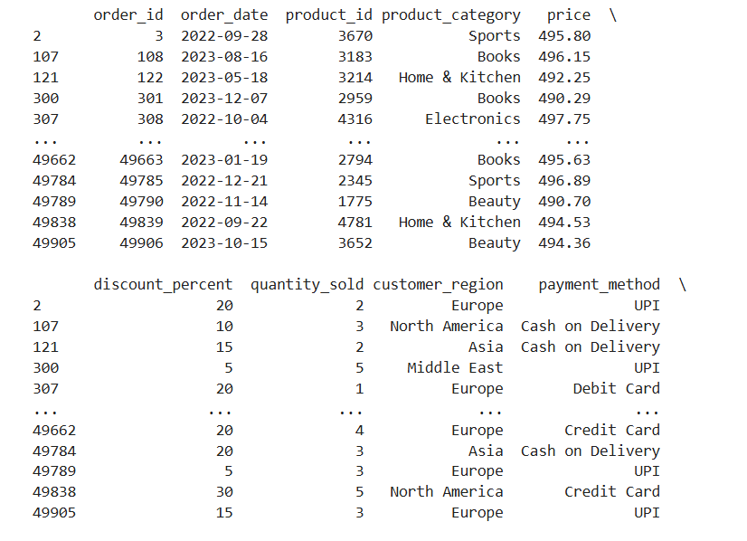
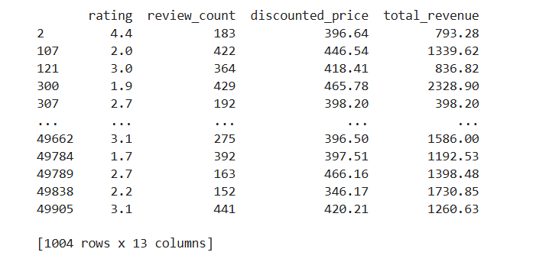

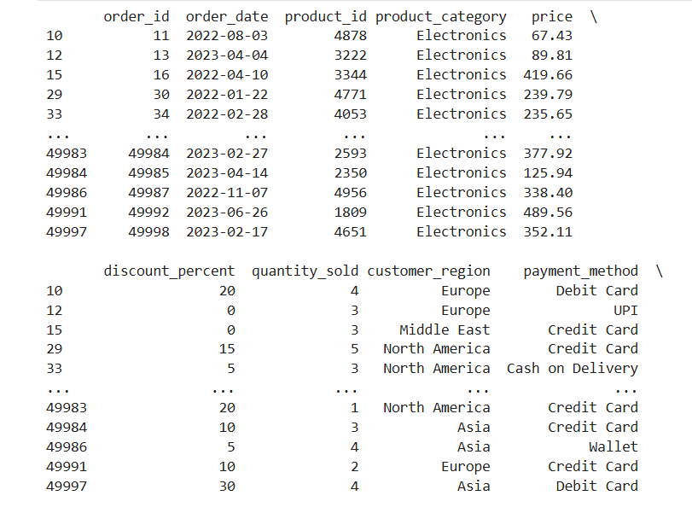
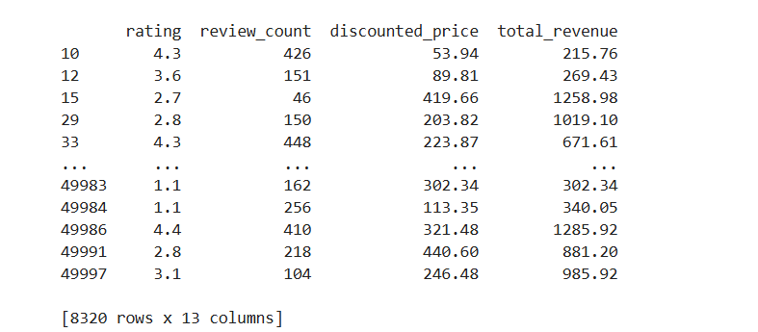

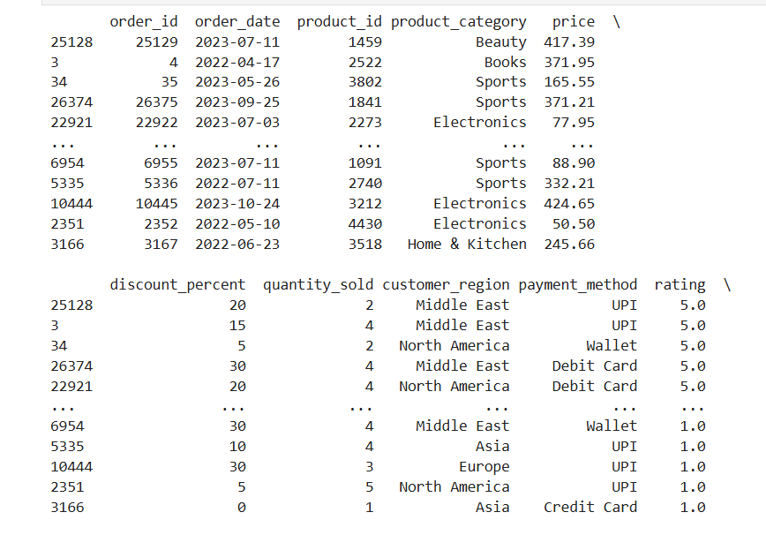
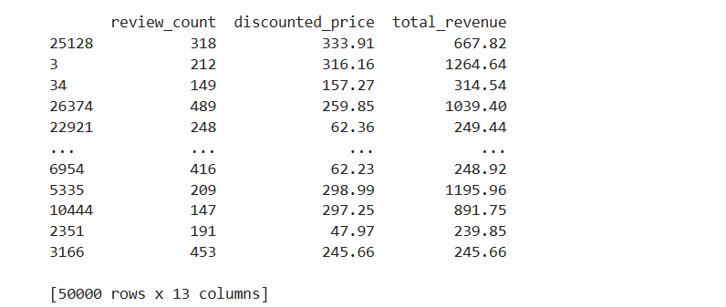

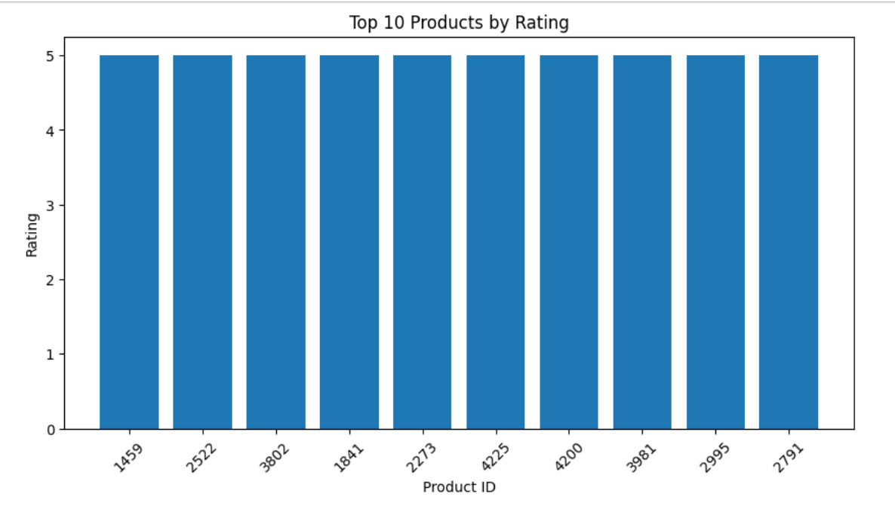

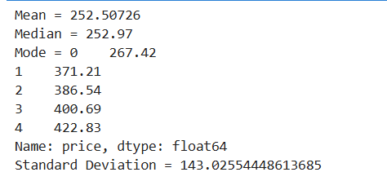

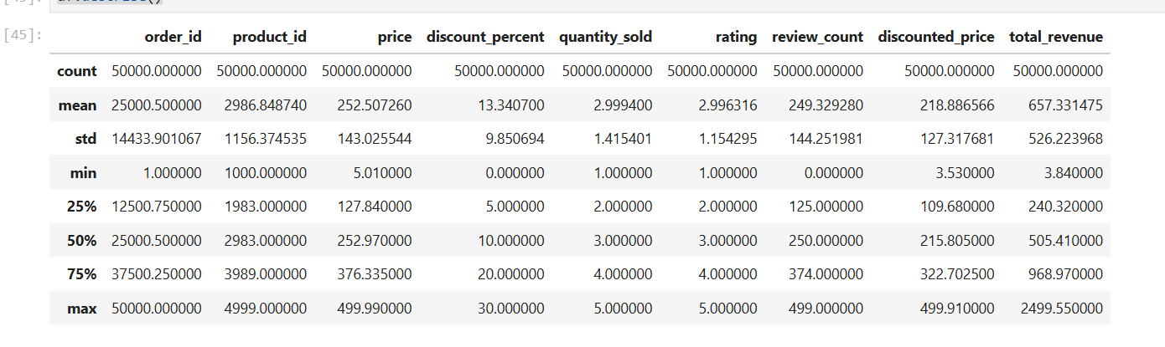
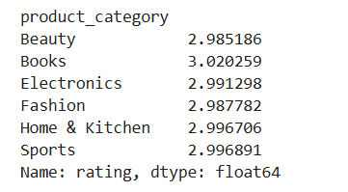

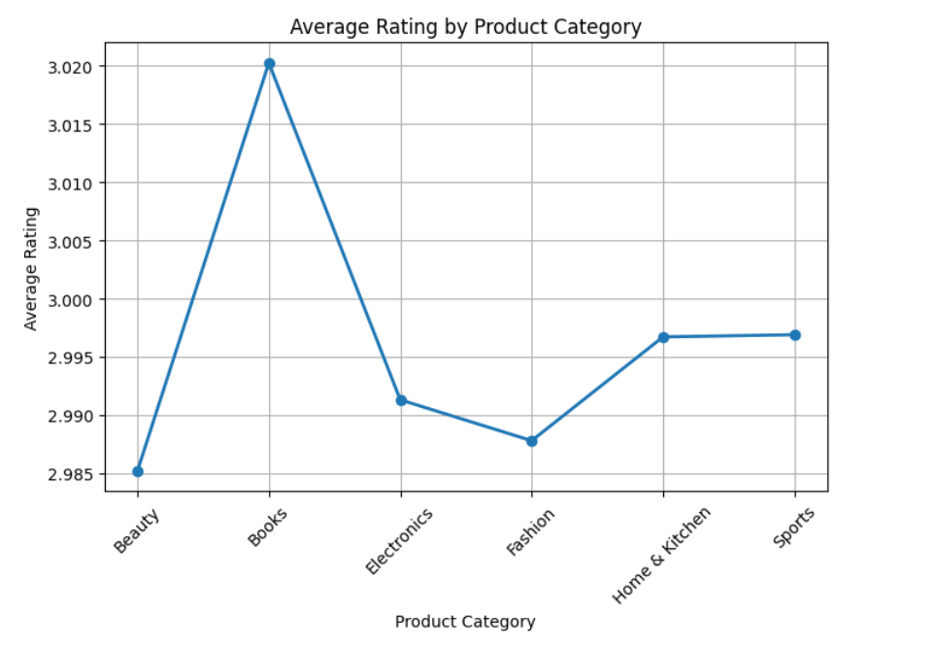

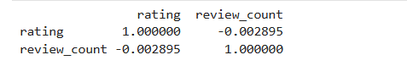

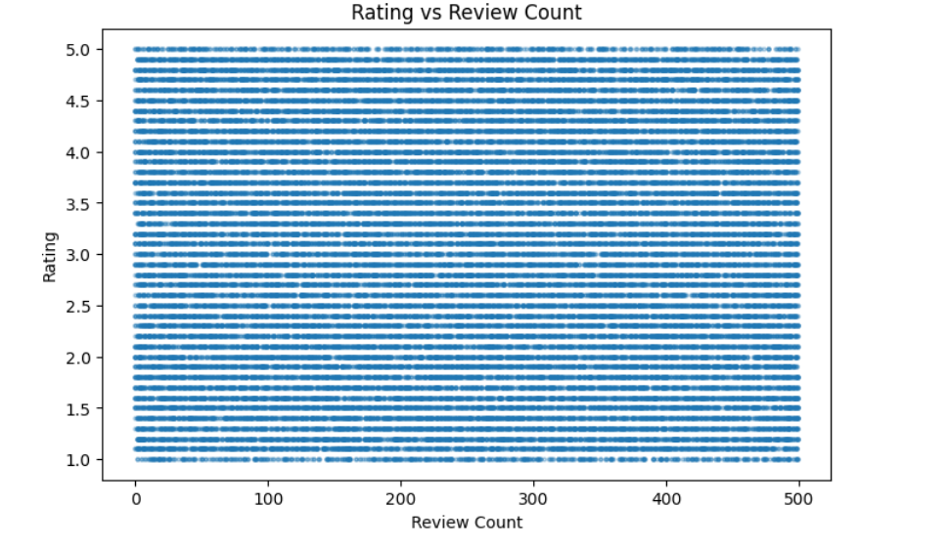

RESULT
Thus, data inspection, filtering, sorting, descriptive statistical analysis, grouping, aggregation, and correlation analysis were successfully performed using Pandas. The analytical results were visualized and interpreted successfully.

